Mounting brackets

Having looked at the many proprietary options available, I decided to go for a DIY approach rather than spending £100+ on bracketry.

I considered making my own ‘under-beak’ brackets, but in the end went for the easy option, mounting on the crash bars. These are 1” dia, and I remembered previously mounting stuff to similar sized stanchions on a yacht… so a quick trip to my local chandlery and I came up with the following:

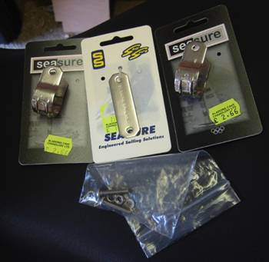
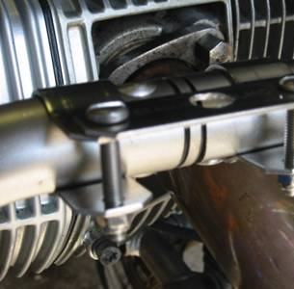
Take 2off 1” stainless steel clamps and 1off backing plate (meant to go with U-clips); drill 10mm hole in plate and mount across the clamps, using M5 x 30mm stainless bolts and nylock nuts. Total cost £15.50

The assembly just about bridges the join in the crash bars, avoiding the screw head on one part and weld blob on the other.

Lights

Extensive research let me to the simplified conclusion that:
- PIAAs are the best, but too bloody expensive for what I want
- Hella FF50s are the best reasonably-prices option – good light output, compact size and the style matches the GS headlights well. I went for the spots rather than the fogs.

I ordered a set from a German seller via eBay, and they arrived a few days later.
I was please to find that the kit includes not only two lights, bulbs and brackets, but also a relay, switch (which I didn’t use), wire and various crimp connectors.

To mount the lights on my brackets I used the supplied nuts as spacers and added stainless nylock nuts from my spares stock.

Wiring

OK, now the daunting bit. Despite being trained (many years ago) as an Electrical and Electronics Engineer, I was paranoid about screwing things up on my nearly-new-ten-grand-state-of-the-art bike. However, with a couple of hints from UKGSer bods (thanks Mouse and Wizard) and a slow-plodding approach, it all went smoothly and I was pleased with the result.
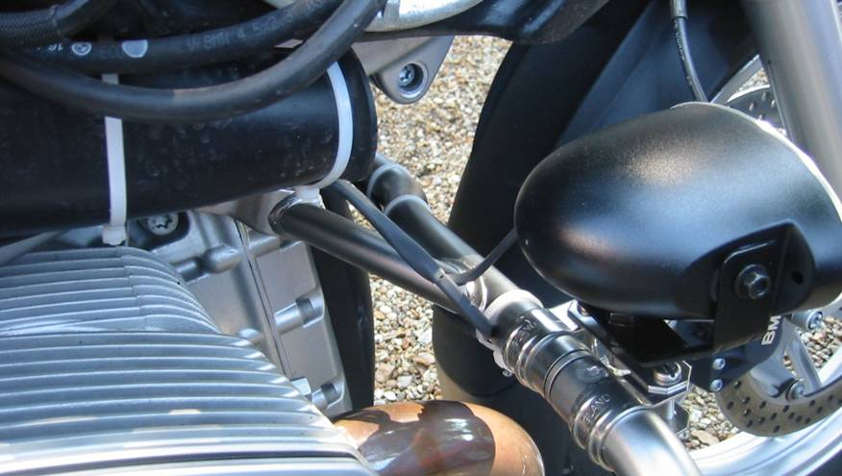
I used short lengths of heatshrink sleeving to keep the wiring tidy and also to protect against chafing at various points, and tiewraps to hold it in place.

(Black tiewraps would have been better, but I only had ‘natural’ white ones).

This is pretty much the sequence of events:
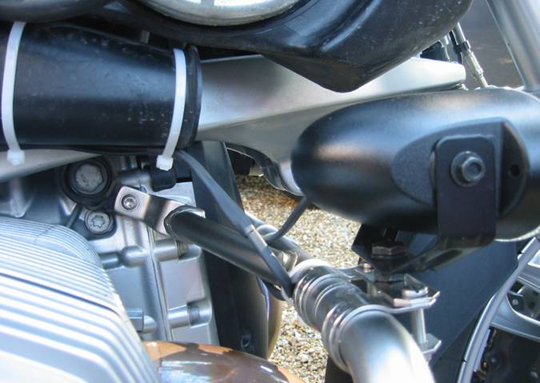
- Connect a pair of wires to LHS spot lamp; tidy up the pair with heatshrink and tiewrap them across the top of the crash bar to the RHS lamp.
- Connect a pair of wires to RHS spot lamp; heatshrink the pair where it emerges from the lamp but then pick up the LHS pair and heat-shrink all 4 wires together into one loom.
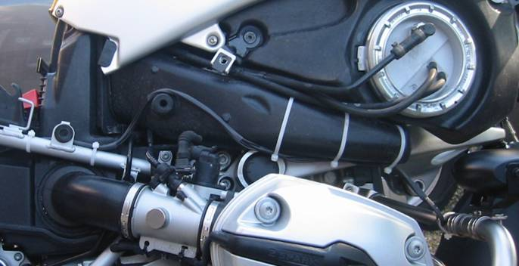
- Route the loom along the RHS of the bike, tie-wrapping it to the air intake and then the frame. When you get to the battery compartment split the loom into two positives and two negatives.
- Route the negatives towards the negative battery terminal, then add a 3rd wire to the 2 negatives before crimping on a ring tag to connect to the battery terminal.

So far so good? OK…
- Route the two positives to the space under the tool tray; leave a bit of slack for positioning then crimp on a spade terminal to the pair together. This is the positive feed to your lights, switched by the relay… connect it to relay terminal 87.
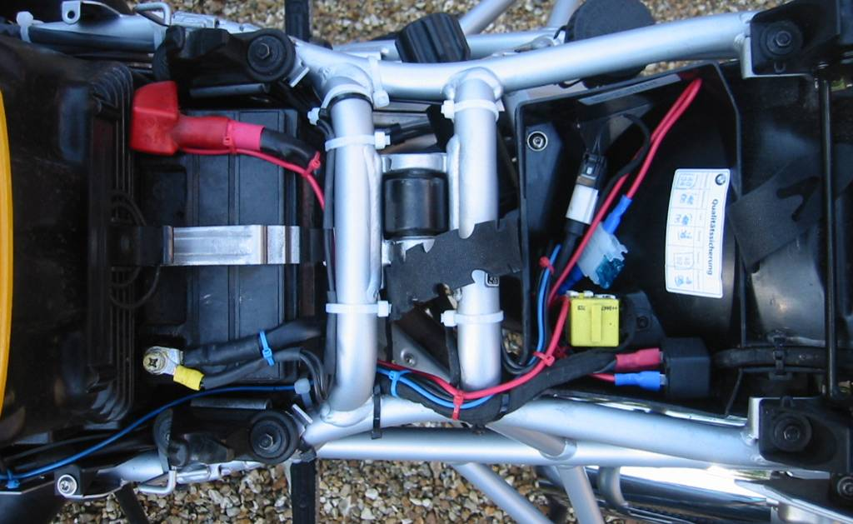
- Take the ‘spare’ negative wire that you added in 4), and route this to the space under the tool tray; again, leave a bit of slack (same as in the positives) for positioning, then crimp on a spade terminal. This is the negative for the relay coil… connect it to relay terminal 86.
- Connect a ring tag to a spare bit of wire for the positive feed from the battery. (DON’T CONNECT IT YET!!). I used red wire (cos I had some!). Again, route this to the space under the tool tray and crimp on a spade terminal… but leaving less slack this time as this is going to your fuse, not the relay. Make up a short piece of wire with a spade terminal on each end to go from the fuse to the relay. This gives you your fused positive supply that will connect to the positive feed to the lights via the relay... connect it to relay terminal 30.
OK, nearly there.
All you need now is a signal to switch on the relay when you switch on your headlights….

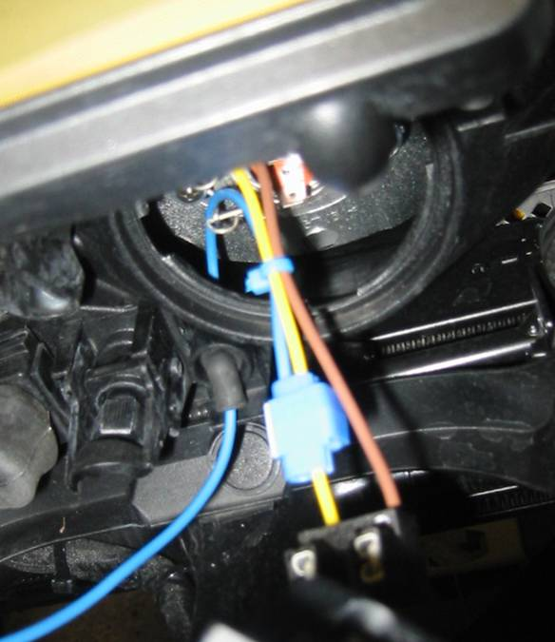
- Open up the twist-off access panel at the rear of your dipped headlight*. Inside is a pair of wires going to the back of the bulb – you will need to connect to the YELLOW one*… but don’t connect it yet, read the next bit!
At the bottom of the back of the headlight there is a small rubbery grommet thinghy – presumably for ventilation. Wit a bit of careful wiggling you can feed a wire into this from the rear, so that it goes through into the inside of the headlight assembly. Once you’ve done this you can connect it to the yellow headlight wire using a Scotchlock type connector (you just clamp it into place; it pierces the insulation on the wires). I used a blue wire just to make it obvious to distinguish form the others (and I had some spare).

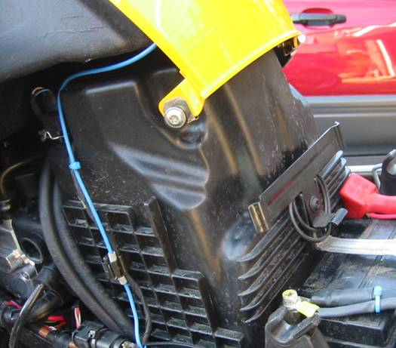
- Route your trigger wire back from the headlight, cable-tying it alongside the existing wiring loom. thread it under the tank cover plastic. When it emerges at the back route it down the left-hand side, tying it onto the existing loom then routing back to your relay under the tool tray… connect it to relay terminal 85.

- OK, nearly ready to try it. But first, one final tip… cut of the tails off all your tie-wraps first – if they touch the exhaust downpipes the melt, burn and stink!

- Check all your connections, make sure all your wiring’s secure, tuck the fuse and relay neatly into the under-too-tray and reconnect your battery. Then go for it! If all’s well you now have a beautiful new pair of spots that come on with both high and low beam.*

*Obviously if you want the lights on with high beam only, just take the relay feed from the back of the high beam bulb instead.
Approximate routing (not to scale!)

Relay
Fuse
(15A)
Negative
Switched Positive
Fused Positive feed
Relay Trigger

+

-
Relay
Fuse
12V
Fused 12V
Switched 12V
0V

Paul's 1200GS Spotlight project
Parts List
eBay - autoteile-hrgrossmann (Germany)
Hella FF50s kit  (Includes 2 lamps, wire, relay, switch, crimp tags, scotchlock connectors etc) | 1 | £ 31.83 | £ 31.83
Postage (Including Vision Plus H7 bulbs - see below) | 1 | £ 9.00 | £ 11.17
 |  |  | £ 43.00
Aladdin's cave (yacht chandlery)
s/s Panel clip 1" | 4 | £ 2.66 | £ 10.64
s/s Backing plate | 2 | £ 1.61 | £ 3.22
s/s M5 Machine screw pan head M5 x 30 | 4 | £ 0.25 | £ 1.00
s/s M5 Full nut (nylock) | 4 | £ 0.11 | £ 0.44
s/s M5 Plain washer | 4 | £ 0.05 | £ 0.20
In-line blade fuse holder (pack 2) | 1 | £ 2.90 | £ 2.90
15A Blade fuse (pack 5) | 1 | £ 0.90 | £ 0.90
 |  |  | £ 19.30
Halfords
15A spade connector (pack 5) | 2 | £ 1.09 | £ 2.18
B&Q
Heatshrink sleeving (small dias pack) | 2 | £ 1.78 | £ 3.56
 |  | Total | £ 68.04
Paul's garage stock
Cable ties (various) | Lots
M8 s/s nylock nut | 2
Blue wire, 8A | 3m
Red wire, 8A | .5m
Odd crimp connectors
Also from eBay - autoteile-hrgrossmann (Germany)
Pack of 2off H7 PHILIPS XENON GAS +50% VISION PLUS 12V 55W | 1 | £ 13.13 | £ 13.13
(Not required for FF50s, but bought at the same time to upgrade main headlight bulbs)
NOTE: NIPPY NORMAN SPECIAL OFFER PRICE FOR SAME WAS £19.99 +P&P
Total including headlight upgrade |  |  | £ 81.17


